Use this resource to remove the advisor hold on a student profile.

Students with an advising hold will be required to meet with an academic advisor. An advising hold will prevent a student from registering for classes until a meeting occurs. At the conclusion of the advising meeting, the advisor will remove the registration hold making the student eligible to register for classes.

To remove the advisor hold, you must: STEP 1 View Student Action Items and Holds STEP 2: Remove the advisor hold

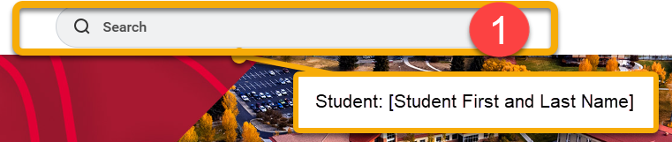
INSTRUCTIONS
STEP 1: Access Student Action Items and Holds
- Log into Workday. In the search bar, type Student: [Student’s first and last name]. Click the student record once it auto-populates.
- From the student profile, scroll down the left-side menu and click “Action Items and Holds”.
- Review Action Items, Active Holds, and Resolved Holds.

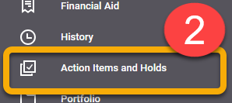

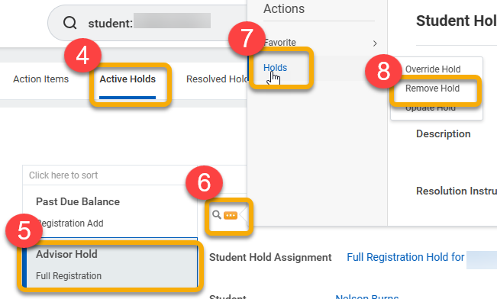
STEP 2: Remove the Advisor Holds
- From the student profile, click the “Active Holds” tab
- Click “Advisor Hold”.
- Hover over the magnifying glass to reveal the Related Actions button and click.
- Hover over “Holds”.
- Click “Remove Hold”. Review the Remove Student Holds page. When finished, scroll down to click the “Confirm” box and “Submit”.

Use this resource to remove the advisor hold on a student profile.

Students with an advising hold will be required to meet with an academic advisor. An advising hold will prevent a student from registering for classes until a meeting occurs. At the conclusion of the advising meeting, the advisor will remove the registration hold making the student eligible to register for classes.

To remove the advisor hold, you must:

STEP 1: View Student Action Items and Holds
STEP 2: Remove the advisor hold

INSTRUCTIONS

STEP 1: Access Student Action Items and Holds

- Log into Workday. In the search bar, type “Student: [Student’s first and last name]”. Click the student record once it auto-populates.

- From the student profile, scroll down the left-side menu and click “Action Items and Holds”.
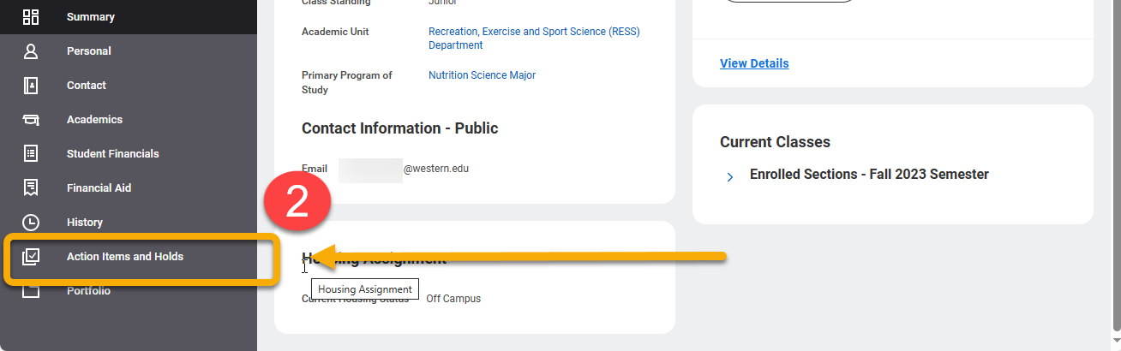
- Review Action Items, Active Holds, and Resolved Holds. The advisor hold is found in the Active Holds tab.

Item | Description
Action Items | View active items in Financial Aid, Admissions and Onboarding.
Active Holds | View active holds, descriptions, resolution instructions and what activities the hold prevents.
Resolved Holds | Review history of holds, reasons for holds, descriptions, resolution instructions, hold types, date resolved and who the hold was removed by.

STEP 2: Remove the Advisor Hold

- From the student profile, click the “Active Holds” tab

- Click “Advisor Hold”.
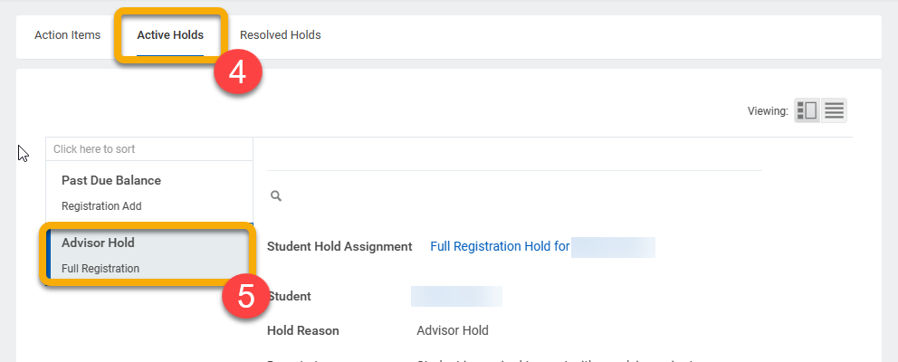

- Hover over the magnifying glass to reveal the Related Actions button and click.
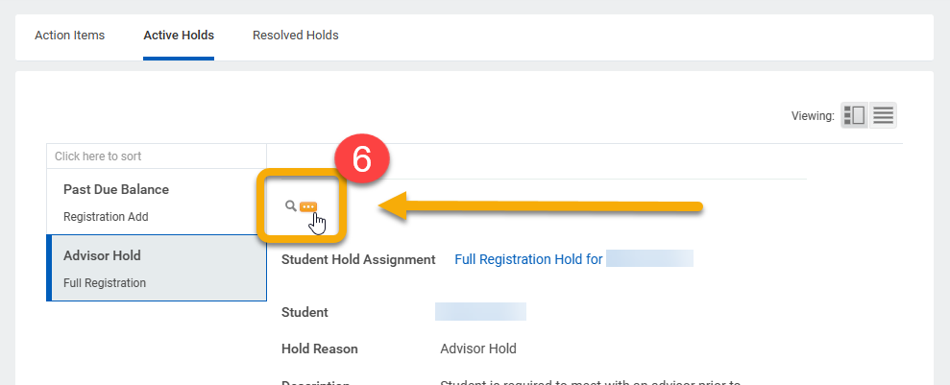
- Hover over “Holds”.

- Click “Remove Hold”.
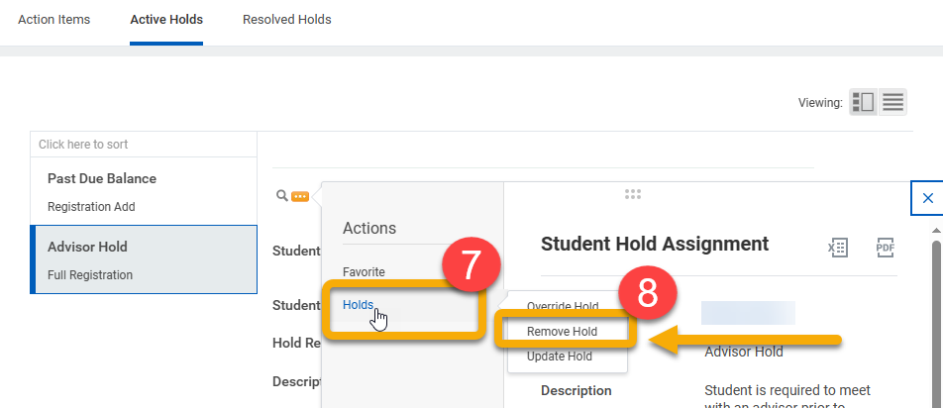

- Review the Remove Student Holds page. When finished, scroll down to click the “Confirm” box and “Submit”.

